// program to sort an array

class ArraySort

{

public static void main(String args[])

{

int a[] = {8,2,9,6,1};

int temp =0;

System.out.println("Elements before sorting ");

for(int i =0;i<a.length;i++)

{

System.out.print(a[i]+" ");

}

for(int i=0;i<a.length;i++)

{

for(int j=i+1;j<a.length;j++)

{

if(a[i]>a[j])

{

temp = a[i];

a[i] = a[j];

a[j] = temp;

}

}

}

System.out.println();

System.out.println("Elements after sorting ");

for(int i=0;i<a.length;i++)

{

System.out.print(a[i]+" ");

}

}

}

**OUTPUT:**

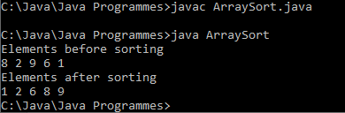

// program to find difference of two matrix

class MatrixDiff

{

public static void main(String args[])

{

int a[][] = {{10,20,30},{40,50,60},{70,80,90}};

int b[][] = {{90,80,70},{60,50,40},{30,20,10}};

int sum[][] = new int[10][10];

System.out.println("Difference of matrix a and matrix b is ");

for(int i =0;i<a.length;i++)

{

for(int j=0;j<b.length;j++)

{

sum[i][j] = a[i][j]-b[i][j];

System.out.print(sum[i][j]+" ");

}

System.out.println();

}

}

}

**OUTPUT:**

